VISVESVARAYA TECHNOLOGICAL UNIVERSITY
Jnana Sangama, Belagavi – 590018


Report on
CONVENTIONAL AND NON-CONVENTIONAL SOURCES OF ENERGY

BACHELOR OF ENGINEERING IN
ARTIFICIAL INTELLIGENCE AND DATA SCIENCE
Submitted By:

MAREDDY CHARAN 1SJ22AD024
A CHETAN 1SJ22AD005
Y REVANTH 1SJ22AD063
M AKASH 1SJ22AD021
N SREEDHAR 1SJ22AD027

UNDER THE GUIDANCE OF

VATHSALA M N ASSISTANT PROFESSOR
DEPARTMENT OF CIVIL ENGINEERING, SJCIT


SJC INSTITUTE OF TECHNOLOGY
DEPARTMENT OF ARTIFICIAL INTELLIGENCE AND DATA SCIENCE, CHICKBALLAPUR-562101
2024-2025

ABSTRACT

Energy is the cornerstone of human development and technological advancement, playing a vital role in shaping economies and societies worldwide. Broadly, energy sources are classified into conventional and non-conventional categories, each contributing uniquely to the energy landscape. Conventional energy sources, such as coal, petroleum, natural gas, and nuclear power, have long been the primary drivers of global energy production due to their availability and well-established extraction technologies. However, these resources are finite, environmentally detrimental, and contributors to climate change, necessitating a transition toward sustainable alternatives.
Non-conventional energy sources, including solar, wind, geothermal, hydroelectric, and biomass energy, represent a paradigm shift toward cleaner, renewable, and environmentally friendly options. These resources are inexhaustible and harness energy from natural processes, making them vital for achieving long-term energy security and addressing environmental concerns. The increasing focus on these sustainable sources aligns with global commitments to reduce greenhouse gas emissions and combat the adverse effects of climate change.
This report explores the characteristics, advantages, and limitations of both conventional and non-conventional energy sources. It delves into their role in meeting current and future energy demands while emphasizing the importance of balancing energy needs with environmental preservation. By fostering a deeper understanding of these energy systems, this report aims to underscore the critical importance of transitioning to a sustainable energy future that prioritizes innovation, resilience, and environmental stewardship.

TABLE OF CONTENTS
SL.NO | CONTENTS | PAGE NO
1 | Introduction | 1
2 | Conventional Sources Of Energy | 2
3 | Types of conventional sources of energy | 2-4
4 | Advantages of Conventional Energy Sources | 4
5 | Limitations of Conventional Energy Sources | 5
6 | Non-Conventional Sources Of Energy | 6
7 | Types of Non-Conventional Sources of Energy | 6-8
8 | Advantages of Non-Conventional Energy Sources | 8
9 | Limitations of Non-Conventional Energy Sources | 9
10 | Comparison between Conventional and Non-Conventional Sources of Energy | 10
11 | Conclusion | 11

CONVENTIONAL AND NON-CONVENTIONAL SOURCES OF ENERGY
INTRODUCTION
Energy is an indispensable component of modern civilization, driving industries, transportation, and daily life. As the global population grows and technological advancements expand, the demand for energy continues to rise, making it imperative to understand and utilize various energy sources effectively. Broadly, energy sources are categorized into two types: conventional and non-conventional. These two groups play a pivotal role in shaping energy policies, economic growth, and environmental sustainability.
Conventional energy sources, such as coal, oil, natural gas, and nuclear power, have historically served as the backbone of energy production worldwide. Their widespread availability and established infrastructure have enabled them to dominate global energy markets for decades. However, the extensive use of these fossil fuels has led to critical environmental challenges, including air pollution, global warming, and the depletion of finite natural resources.
On the other hand, non-conventional energy sources, such as solar, wind, geothermal, hydroelectric, and biomass energy, represent a cleaner, renewable, and more sustainable alternative. With growing awareness of environmental concerns and the urgent need to mitigate climate change, non-conventional energy has emerged as a viable solution to reduce dependence on fossil fuels and transition toward a greener future.
This report aims to provide a comprehensive analysis of both conventional and non-conventional energy sources. It explores their characteristics, benefits, limitations, and their respective roles in addressing the global energy crisis. By examining the potential of non-conventional energy to complement or replace conventional sources, the report highlights the need for innovative strategies to achieve a sustainable energy future.

CONVENTIONAL SOURCES OF ENERGY
Energy is a fundamental requirement for economic development and societal progress. Conventional sources of energy also referred to as traditional or non-renewable energy sources, have historically been the primary drivers of industrial growth and technological advancements. These energy sources are derived from natural resources that have been used extensively for decades due to their high energy density and established extraction technologies. However, their finite availability and environmental impact have raised concerns about their long-term sustainability.

Definition of Conventional Sources of Energy:
Conventional sources of energy are those energy resources that are obtained from finite natural reserves such as fossil fuels and nuclear materials. These resources are often referred to as non-renewable because they take millions of years to form and are depleted faster than they can regenerate. Conventional energy sources are typically harnessed through well-established technologies and infrastructure, making them the most widely used energy resources globally.

Types of Conventional Sources of Energy:

Coal
Coal is one of the oldest and most abundant fossil fuels used for energy production. It is primarily composed of carbon along with varying amounts of hydrogen, sulfur, oxygen, and nitrogen. Coal is widely used in power generation, industrial processes, and as a raw material in the production of steel and cement.
There are four main types of coal
- Anthracite: The highest carbon content and energy output.
- Bituminous: Commonly used for electricity generation and industrial applications.
- Sub-bituminous: Lower energy content but widely used in power plants.
- Lignite: Lowest energy content, mainly used for electricity generation.

Petroleum (Oil)
Petroleum is a liquid fossil fuel formed from the remains of ancient marine organisms. It is refined into various products such as gasoline, diesel, jet fuel, and heating oil. Petroleum is extensively used in transportation, industrial applications, and as a feedstock for petrochemical products like plastics and fertilizers.
While petroleum is highly versatile and energy-dense, its extraction, refining, and combustion processes result in significant greenhouse gas emissions, oil spills, and other environmental hazards.

Natural Gas
Natural gas is a cleaner-burning fossil fuel composed primarily of methane (CH4). It is widely used for electricity generation, heating, and as an industrial fuel. Natural gas is often found in association with oil deposits and can be transported through pipelines or liquefied for export.
Compared to coal and oil, natural gas produces fewer emissions of CO2 and other pollutants. However, methane leaks during extraction and transportation can significantly impact the environment, as methane is a potent greenhouse gas.

Nuclear Energy
Nuclear energy is derived from the fission of uranium or plutonium atoms in a controlled reaction. The process releases a tremendous amount of heat, which is used to generate steam and drive turbines to produce electricity. Nuclear power plants are highly efficient and produce minimal greenhouse gas emissions during operation.
Despite its advantages, nuclear energy poses challenges such as the disposal of radioactive waste, high costs of construction and decommissioning, and the potential for catastrophic accidents, as evidenced by incidents like Chernobyl and Fukushima.

Hydropower (Traditional)
Although hydropower is often considered renewable, traditional large-scale hydroelectric projects are sometimes classified under conventional energy due to their long-standing use and significant environmental impact. Hydropower involves harnessing the energy of flowing or falling water to generate electricity. It is a reliable and consistent energy source but can disrupt ecosystems, displace communities, and alter water flow patterns.
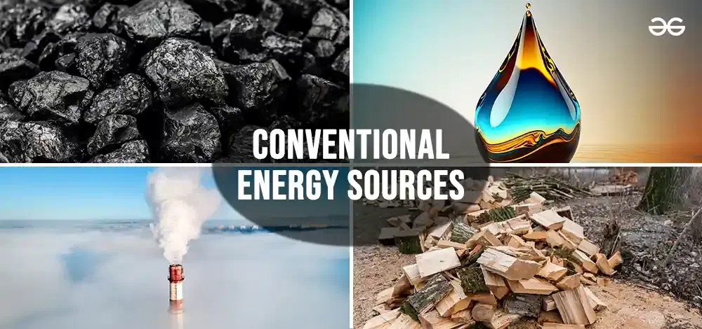

Advantages of Conventional Energy Sources:
- High Energy Density: Conventional sources like coal, oil, and natural gas provide a high amount of energy per unit, making them suitable for large-scale industrial applications.
- Established Infrastructure: Decades of investment in extraction, transportation, and utilization technologies make these sources readily accessible.
- Consistent Supply: Conventional sources can provide a stable and reliable energy supply, especially for base-load electricity generation.
- Economic Growth: The exploitation of fossil fuels has historically fueled economic development and industrialization worldwide.

Limitations of Conventional Energy Sources:
- Finite Resources: Conventional energy sources are non-renewable and will eventually be depleted.
- Environmental Impact: The extraction, processing, and combustion of fossil fuels release significant greenhouse gases and pollutants, contributing to climate change and environmental degradation.
- Health Hazards: Air and water pollution caused by conventional energy sources can lead to severe health issues for humans and wildlife.
- Geopolitical Conflicts: The uneven distribution of fossil fuel reserves often leads to geopolitical tensions and energy insecurity.

NON-CONVENTIONAL SOURCES OF ENERGY
Energy is a fundamental driver of economic growth and sustainable development. As the global demand for energy increases, the reliance on conventional sources such as fossil fuels has led to environmental degradation, resource depletion, and climate change. In response, non-conventional energy sources, also known as renewable or alternative energy sources, have emerged as sustainable solutions to address these challenges. These energy sources are derived from natural, renewable processes that are environmentally friendly and inexhaustible.

Definition of Non-Conventional Sources of Energy:
Non-conventional sources of energy refer to renewable and sustainable energy resources that are harnessed from natural phenomena such as sunlight, wind, water, and geothermal heat. These sources are replenished naturally and do not deplete over time. Unlike conventional energy, non-conventional energy is clean, produces minimal environmental impact, and contributes to reducing greenhouse gas emissions.

Types of Non-Conventional Sources of Energy:

Solar Energy
Solar energy is harnessed from the sun's radiation and is one of the most abundant energy sources available on Earth.
It is captured using technologies such as:
- Photovoltaic (PV) Cells: Convert sunlight directly into electricity.
- Solar Thermal Systems: Use sunlight to generate heat for water heating, cooking, or electricity production.
- Concentrated Solar Power (CSP): Uses mirrors or lenses to concentrate sunlight and produce high-temperature heat for electricity generation.
Solar energy is widely used for residential, industrial, and agricultural purposes. It is sustainable, inexhaustible, and pollution-free, although it requires significant initial investment and is dependent on weather conditions.

Wind Energy
Wind energy is generated by converting the kinetic energy of wind into electricity using wind turbines. Wind farms, comprising multiple turbines, are often established in areas with consistent and strong wind patterns, such as coastal regions and open plains.
Wind energy is renewable, efficient, and environmentally friendly, producing no emissions during operation. However, it requires large land areas, can impact local wildlife, and is subject to variability depending on wind availability.

Hydropower (Small-Scale)
Unlike large-scale hydropower projects, small-scale hydropower systems harness energy from flowing or falling water in rivers or streams to generate electricity. These systems are ideal for remote and rural areas.
Hydropower is renewable and reliable, but it can disrupt aquatic ecosystems and requires suitable geographical conditions for effective operation.

Biomass Energy
Biomass energy is derived from organic materials such as agricultural residues, animal waste, wood, and dedicated energy crops. These materials are burned or processed to produce heat, electricity, or biofuels like ethanol and biodiesel.
Biomass energy is renewable and helps in waste management. However, its combustion can produce emissions, and its large-scale use may compete with food production and land use.

Geothermal Energy
Geothermal energy is obtained by harnessing heat from the Earth's interior. This energy is used for electricity generation, space heating, and industrial processes. Geothermal power plants are typically located in geologically active regions with high geothermal activity.
Geothermal energy is highly efficient, reliable, and environmentally friendly. However, it is location-specific and requires significant upfront investment for exploration and infrastructure.
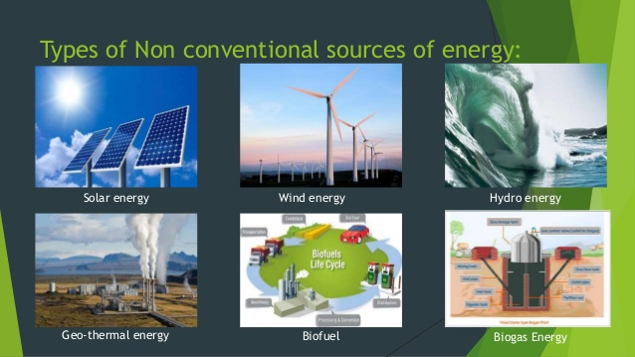

Advantages of Non-Conventional Energy Sources:
- Sustainability: These sources are renewable and inexhaustible, ensuring long-term energy security.
- Environmentally Friendly: Non-conventional energy produces minimal greenhouse gas emissions and pollutants.
- Energy Independence: Countries can reduce their dependence on imported fossil fuels by utilizing locally available renewable resources.
- Economic Benefits: Investment in renewable energy creates jobs, stimulates local economies, and fosters technological innovation.
- Decentralization: Many renewable energy systems can be deployed in remote and rural areas, providing access to energy for underserved populations.

Limitations of Non-Conventional Energy Sources:
- High Initial Costs: The installation of renewable energy systems requires significant upfront investment.
- Intermittency: Solar and wind energy are dependent on weather conditions, leading to variability in energy production.
- Geographical Constraints: Some resources, such as geothermal and tidal energy, are location-specific and not universally accessible.
- Technological Challenges: Continued research and development are needed to improve efficiency, reduce costs, and address environmental impacts.

COMPARISON BETWEEN CONVENTIONAL AND NON-CONVENTIONAL SOURCES OF ENERGY
Availability
- Conventional Sources: Derived from finite resources such as coal, oil, and natural gas, which take millions of years to form and are exhaustible.
- Non-Conventional Sources: Derived from renewable resources like solar, wind, and geothermal energy, which are naturally replenished and virtually inexhaustible.
Environmental Impact
- Conventional Sources: Cause significant environmental degradation, including greenhouse gas emissions, air and water pollution, and habitat destruction.
- Non-Conventional Sources: Environmentally friendly, with minimal emissions and lower ecological footprints.
Technological Maturity
- Conventional Sources: Utilized for centuries with well-developed technologies and established industries.
- Non-Conventional Sources: Still evolving, with ongoing advancements needed to improve efficiency and cost-effectiveness.
Energy Density
- Conventional Sources: Offer high energy density, making them suitable for large-scale industrial use.
- Non-Conventional Sources: Generally lower energy density, requiring advancements in storage and efficiency for large-scale adoption.

CONCLUSION
The growing global demand for energy has made it essential to explore both conventional and non-conventional energy sources, each offering distinct advantages and challenges. Conventional energy sources, such as coal, oil, and natural gas, have been the cornerstone of industrial development for centuries, providing reliable and cost-effective solutions to meet the energy needs of modern society. However, these fossil fuels are increasingly criticized due to their contribution to environmental degradation, including air pollution, greenhouse gas emissions, and their finite nature. This reliance on non-renewable resources has made it imperative to shift toward more sustainable energy alternatives.
In contrast, non-conventional energy sources such as solar, wind, hydroelectric, and geothermal energy present promising solutions to mitigate environmental impacts and ensure long-term energy security. These renewable sources offer clean, abundant, and sustainable alternatives that are not only environmentally friendly but also increasingly cost-competitive due to advancements in technology and infrastructure. Despite their potential, the adoption of non-conventional energy sources faces challenges related to intermittency, high initial investment, and the need for supportive policy frameworks and infrastructure.
Ultimately, the future of energy lies in the integration of both conventional and non-conventional energy sources. While conventional sources may continue to play a role in meeting immediate energy demands, non-conventional sources will become increasingly important in the transition towards a more sustainable, low-carbon energy landscape. To achieve this, a concerted effort is required to innovate, invest, and develop energy systems that prioritize environmental sustainability while ensuring reliable and equitable energy access for all.
REFERENCES
https://unacademy.com/content/nda/study-material/geography/conventional-and-non-conventional-resources
https://byjus.com/physics/conventional-and-nonconventional-sources-of-energy
https://www.geeksforgeeks.org/conventional-vs-non-conventional-sources-of-energy

